| **STUDENT PORTFOLIO** | |
| --- | --- |
| Harshini new pic.jpg | **Name : Chittamuru Sai Harshini Reddy**  **Register Number:RA2311056010005**  **Mail ID:sc9373@srmist.edu.in**  **Department: DATA SCIENCE AND BUSINESS SYSTEMS(DATASCIENCE)**  **Semester: 3**  **LinkedIn:** **https://www.linkedin.com/in/sai-harshini-reddy-chittamuru-427595287/** |
| **Subject Title: 21CSC201J Data Structures and Algorithm**  **Handled By : Dr. Rajkumar K.** | |
| **ELAB Completion Status Screenshot 2024-10-28 122614.png** | |
| **Screenshot 2024-10-27 221958.png** | |
| **Lab Experiment Completion Status WhatsApp Image 2024-11-06 at 21.39.03_4cbcb643.jpg All the 12 experiments were solved, run and executed successfully and took the completed sign from Faculty.** | |
| **REAL WORLD APPLICATION IN DAA PPT VR/SIMULATION DEMO**  **MUSIC PLAYLIST USING STACK AND QUEUE**  **Screenshot 2024-10-29 185127.png**  **Screenshot 2024-10-29 185226.png**  **Screenshot 2024-10-29 185202.png** | |
| **Screenshot 2024-10-29 185151.png**  **OUTPUT**  **:** **Screenshot 2024-10-28 175810.pngScreenshot 2024-10-28 175834.pngScreenshot 2024-10-28 175827.png** | |
| **Any other**  **(Write if you registered or practise apart from Hackerrank, Leetcode, Github.etc**  **Eg: Certification Programs related to DSA)  Hackerrank and CodeChef**  **Screenshot 2024-10-27 222043.png**  **Screenshot 2024-10-28 122841.png** | |

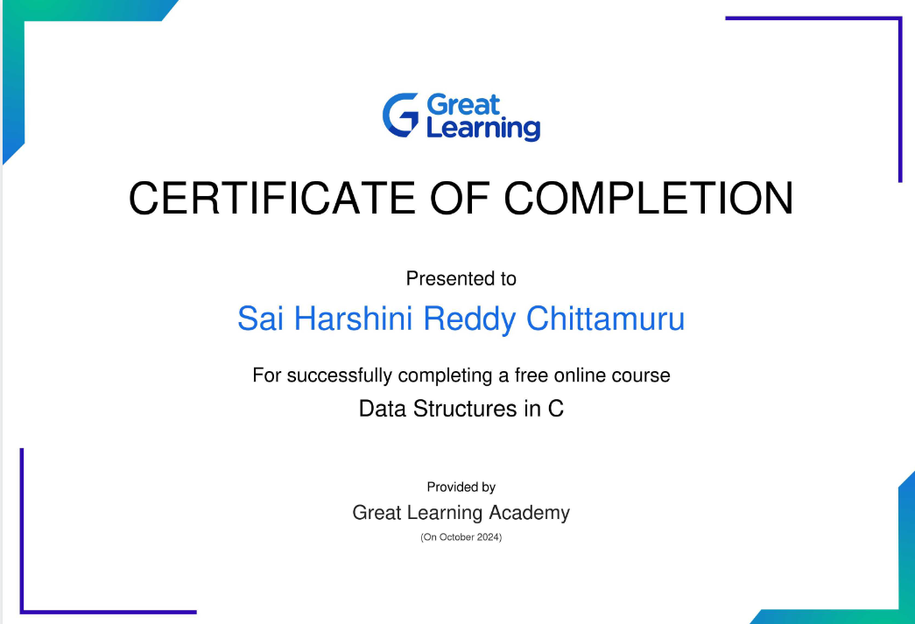

Signature

Chittamuru Sai Harshini Reddy

**